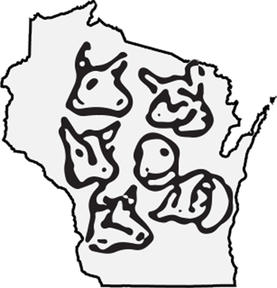

**Six**

Issue

*Letter From the President,*

***in this issue >>>***

***Congrats Winners! >>>***

*Randy Adamson*

*.*



**WDGA Badger Show, West Salem, WI**

**Saturday Ring 1**

BSDIS: Craig Koopman

BJDIS: Katie Denner Stringfield

**Saturday Ring 2**

BSDIS: Craig Koopman

BJDIS:

**Saturday Buck Show:**

Randy and Mary Adamson, Both rings

**Sunday Ring 1**

BSDIS: Randy and Mary Adamson

BJDIS:

**Sunday Ring 2**

BSDIS:Craig Koopman

BJDIS:

**WIS-IL Show, Janesville, WI**

**Senior Show**

**Ring 1:**

**Ring 2:**

**Ring 3:**

**Junior Show**

**Ring 1:**

**Ring 2:**

**Ring 3:**

*Results from the WDGA Badger Show and WIS-IL Spring Shows*

***Wisconsin Dairy Goat Association***

Well, summer seemed to come a little early for most of Wisconsin. Several days with temps in the 90’s at the end of May is way too early! I know it really affected milk production here.

For most of you show season has started, there was a good turnout at the State show in West Salem, and also in Janesville the following week. Speaking of “shows” the WDGA Board is working on a future location for our show. In case you haven’t heard, the WIS-IL show in Janesville will no longer be held. In order to not lose the number of opportunities to attend a show, the WDGA Board is looking into holding a 2-day show, with 3 rings each day. One location that looks promising is the Walworth County fairgrounds in Elkhorn. They have very nice facilities and the price is very reasonable. A major consideration when looking for a new location is labor required to put on a show. At Elkhorn, pens are already set-up and for a reasonable fee they will take care of manure removal. When final location and dates are decided we will let you all know.

Other WDGA news/ideas; I would like to see a committee come together to look into what WDGA can do / offer our commercial dairy goat producers. We are the “Wisconsin Dairy Goat Assoc.”, Wisconsin is #1 in Goat milk production, and we should be doing something for our commercial producers. If you are interested in brain-storming some ideas please contact me.

The BOD also thought it would be fun to offer some type of WDGA “get-together”. A chance to just visit with members. Possibly a meal, or potluck, or? We are thinking something in early winter. Again if you would like to help work on this idea contact me or a board member.

Please consider volunteering to help out on one or more of these events. Your ideas matter and the more people involved the better.

Hope you all have a great summer and good luck in the show ring to those attending shows!

*Letter from the President*

*Youth Corner*

*Meet a Member*

*Classifieds*

*Tips and Tricks, Fun Page*

**Spring 2018 Newsletter**

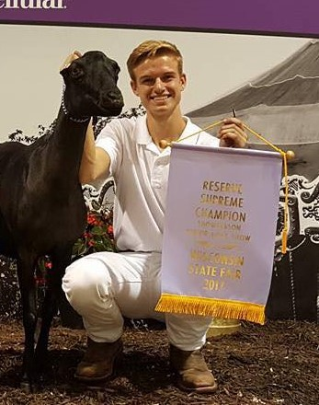

*Congrats Share-a-Kid Winners!*

*Each year, the Wisconsin Dairy Goat Association promotes interest in dairy goats in our state. One of the ways we encourage our young people in this aspect of agriculture is through our Share-A-Kid program. Applicants write an essay of 100 words or more and should tell why they would like to have a dairy goat, how they are going to take care of her (food, shelter, and medical care), if they have ever raised a goat before and if not, who will help them. Also include why they love goats and what they love about goats. Congrats to the following winners below and a HUGE THANK YOU to those who donated kids to these youth!*

*.*

***Youth Corner >>>***

*Meet the New Youth Director: Mason Spencer*

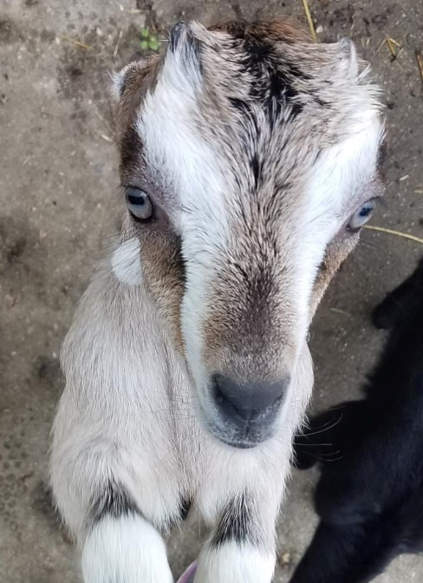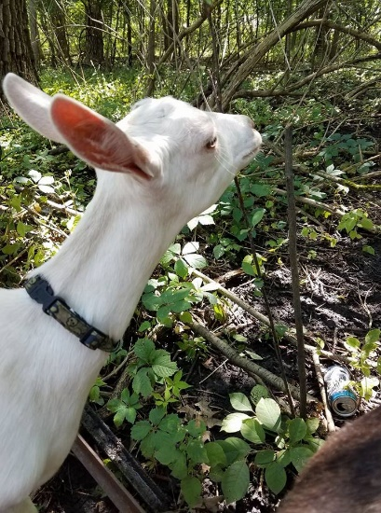

Jadyn Eisenbraun won an Oberhasli kid donated by Jake Hintz

*Jessie Berg won an Oberhasli Kid from Barb Knilans*

Abigail Gatch won a Nigerian Dwarf donated by Becky Gretebeck

*Emmalyn Sprangers won a Nubian from Briana Froseth*

Desiee Ahrens won a LaMancha from Marvin and Becky Mills

*Alexandra Taylor won a Nubian from Randy and Andrea Kuhtz*

Anna Benzing won a Nigerian Dwarf from Kyle Gau (a previous share a kid winner)

CONGRATS EVERYONE!

Every year, a prestigious event called the Dairyland Youth Celebration is held at the Wisconsin State Fair to celebrate the accomplishments of all the youth exhibitors in both the dairy and goat industries. At the Dairyland Youth Celebration, the **Best Dairy Goat in Show and Champion Goat Showperson** are recognized with a $1,000 prize for each winner. However, in order to participate in the distinguished event, the youth goat exhibitors need the support of donors like you! Click the LINK to donate now. Thank you!

*Support our Youth!! !*

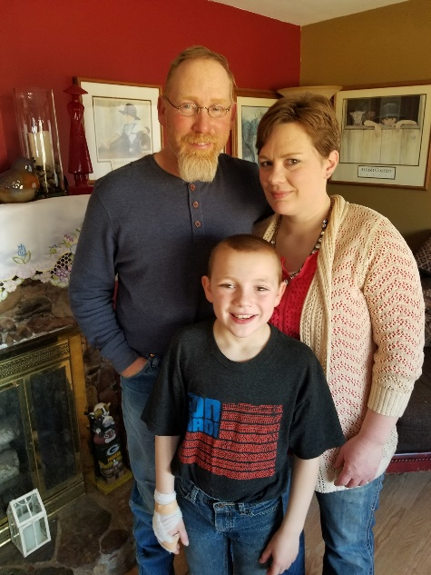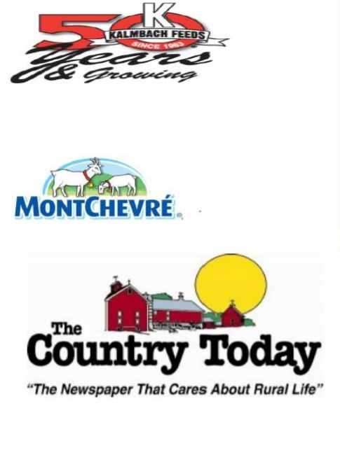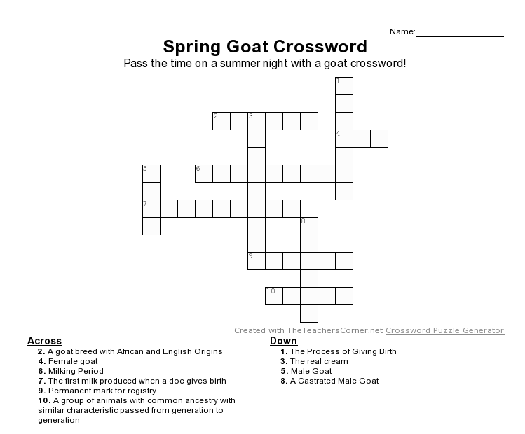

How did you become interested in dairy goats?

*We originally bought 2 doe kids for our son Wyatt for his second birthday. We wanted something for him to learn to take care of and since our cows and horses are a bit big we decided on goats. From there we added a few animals here and there until we got to the point that we either had to sell a bunch or expand to sell milk and make money off of them. So 4 years ago we built a new barn and parlor and expanded the herd.*

What breed(s) do you raise? What is your favorite breed, why?

*We have Toggenburg, the breed we started with and what makes up the bulk of our herd.  We have a few Oberhasli does, they were our second breed added. Wyatt has a herd of 25 Lamanchas and 3 Nigerians. We have Saanens, which we are new to and have fallen in love with their size and productivity. And we do have several recorded grade does, mainly togg/saanen crosses. We each have our own personal favorite breed within the herd but feel that they make up a good mix and a fun herd to work with.*

Do you show?  Tell me about that.

*We do show. We started showing six years ago. We enjoy many aspects of showing from getting to know breeders to seeing other animals and getting ideas of how we want to improve our herd, also ideas of does that we may to use a buck out of.*

How about Linear Appraisal or DHIR?

*We do DHI test once a month, we feel it gives us a wealth of information to use when making management decisions.*

What are your goals for your goats and your farm?

*Our goal is to continue to improve our genetics to produce  structurally sound does that milk well and are healthy.*

What do you find to be the biggest challenge of raising dairy goats?

*The biggest challenge we have had is finding a vet that has experience with goats and is willing to learn and help us.*

What kind of management do you use on your farm? (feed, vaccine, herbs, homeopathy, pasture/paddock).

*We raise all of our kids on colostrum replacer and milk replacer,  vaccinations for CD&T and pnumonia are started as kids and continued every year after, we booster selinium twice a year in the entire herd also. The entire herd is fed grain and high quality balage.*

**Tell us a little about yourself and your farm…...**

How long have you been a WDGA member?

*We have been WDGA members for 7years.*

Where do you live and farm?

*We live/farm just outside of Oshkosh, WI*

How big is your herd?

*We are currently milking 105 does and have 40 dry yearlings to freshen in late fall, 50 doe kids from this year and 12 bucks.*

Do you milk as a hobby, commercially, or ?

*We are a commercial herd, with our milk being shipped to Saputo*.

***Don’t Miss out on these Summer Goat Shows>>>***

*Sheboygan County Youth Fun Show, Sheboygan: June 16*

*Jefferson County Youth Fun Show,Jefferson, June 23*

*Northern Wisconsin State Fair, Chippewa Falls, WI: July 11-15*

*Wisconsin State Fair, Milwaukee, WI: August 10-12*

*Central Wisconsin State Fair, Marshfield, WI: August 23-26*

*Walworth County Fair, Walworth County: August 29-Sept 3*

*The newest addition to the quarterly newsletter, “Meet a Member” is intended to help members get to know each other and how they manage their herds. If you are interested in sharing a bit about yourself with other members, contact Amanda Pauloni at oakalleygoats@gmail.com*

Dairy Goat Parlor Available

*48 Stalls. Waterloo, WI*

*Rent Parlor or Buy Equipment*

*Call Zac at 612-385-4513*

Nubian Bucks Needed for Export

*2 Nubian bucks needed for export. Need to be CAE negative, with silver or speckled ears. Prefer born September 2017-January 2018*

*Contact Dan Considine at 608-334-2009, sunshine@jvlnet.com*

.

*CLASSIFIEDS*

*Meet a Member:*

*The Mills Family*

*WDGA Fall Membership meeting*

*Sunday, November 4 at Noon*

*Pizza Ranch*

*Portage, WI*

1. If you’re using a yogurt maker, simply pour the mixture of fresh milk and starter into the yogurt maker and culture it according to the manufacturer’s instructions for about eight to twelve hours.
2. If you’re using a slow cooker or a cooler, first pour the mixture of starter and raw milk into a 1-quart glass mason jar and cover it with a lid. Place the mason jar full of milk and starter in the center of your slow cooker or cooler and pour warm water (approximately 110° Fahrenheit) into your the ceramic insert or until it reaches just below the lid of your mason jar and leave in a warm spot in your kitchen to culture for eight to twelve hours.
3. Once the culturing period of eight to twelve hours is complete, remove your still warm raw milk yogurt from the yogurt maker, slow cooker, cooler or dehydrator and place it in the refrigerator to chill and solidify for an hour or two.
4. Serve plain as a sauce, combined with fresh fruit or nuts or sweeten it, if desired, with a touch of honey or maple syrup.
5. Credits: Jenny Mcgruther

*Love it? Share it.*

**5.9k**

**SHARES**

[*Share It*](https://www.facebook.com/sharer.php?u=https%3A%2F%2Fnourishedkitchen.com%2Fraw-milk-yogurt%2F)[*Tweet It*](https://twitter.com/intent/tweet?text=How%20to%20Make%20Raw%20Milk%20Yogurt&url=https://nourishedkitchen.com/raw-milk-yogurt/&via=jennynk)[*Pin It*](https://nourishedkitchen.com/raw-milk-yogurt/)[*Mail It*](mailto:?subject=I%20thought%20you%27d%20like%20this%21&body=Check%20out%20this%20article%3A%20https%3A%2F%2Fnourishedkitchen.com%2Fraw-milk-yogurt%2F)



*About Jenny*

Jenny McGruther is a wife, mother and cooking instructor specializing in real and traditional foods. You can find her first book, [*The Nourished Kitchen*](https://nourishedkitchen.com/recommends/nourished-kitchen-cookbook/) features more than 160 wholesome, traditional foods recipes.

*Join Our Community*

*Wholesome cooking doesn’t have to be hard. Sign up to receive recipes and insight on how to eat, live, and thrive – naturally.*

Top of Form

First NameE-Mail Address

Bottom of Form

*Reader Interactions*

*What people are saying*

[*Show Comments*](javascript:;)

*Leave a Reply*

Top of Form

Your email address will not be published. Required fields are marked *

Comment

Name *

Email *

Website

Save my name, email, and website in this browser for the next time I comment.



Bottom of Form

*Primary Sidebar*

Top of Form

Search this website

Bottom of Form

Report this ad

*[https://d2cgumzzqhgmdu.cloudfront.net/assets/small-dd798fdf2451742a7f2a814cbed52a99fedef028b8a1ced99c1e856a2206286c.png](http://www.mediavine.com/)*

GET THE COOKBOOK

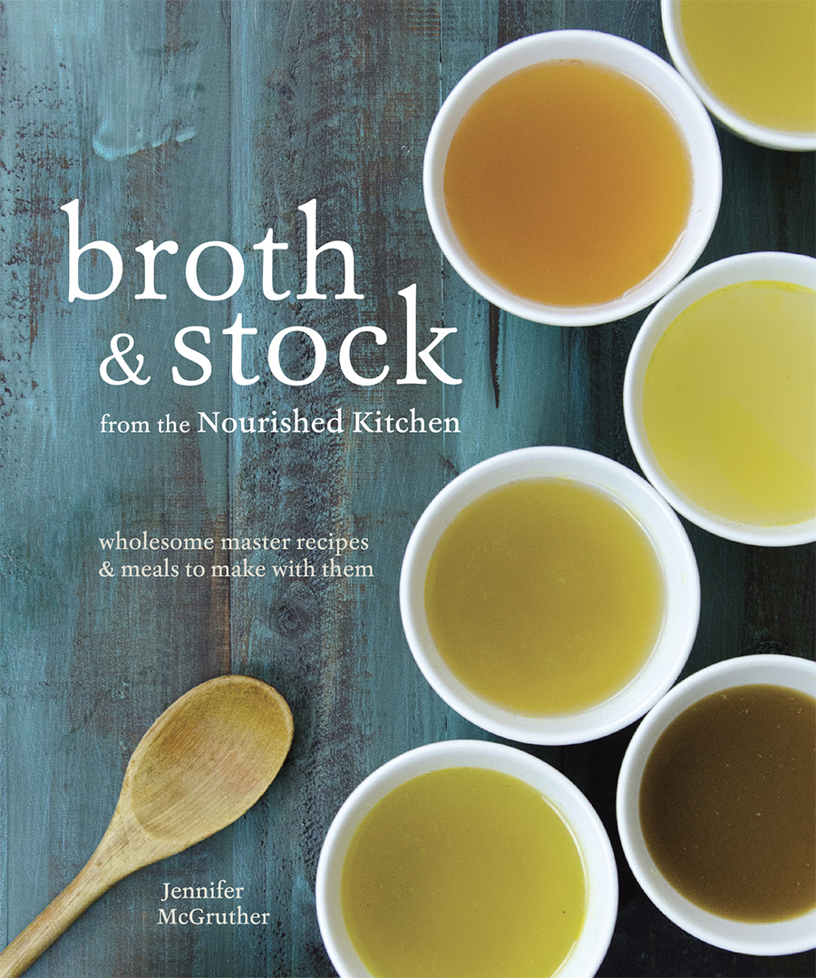  
[*Barnes and Noble*](http://www.barnesandnoble.com/w/broth-and-stock-from-the-nourished-kitchen-jennifer-mcgruther/1122858301) | [*Amazon*](http://amzn.to/1TnBeCa) | [*Indiebound*](http://www.indiebound.org/book/9781607749318)

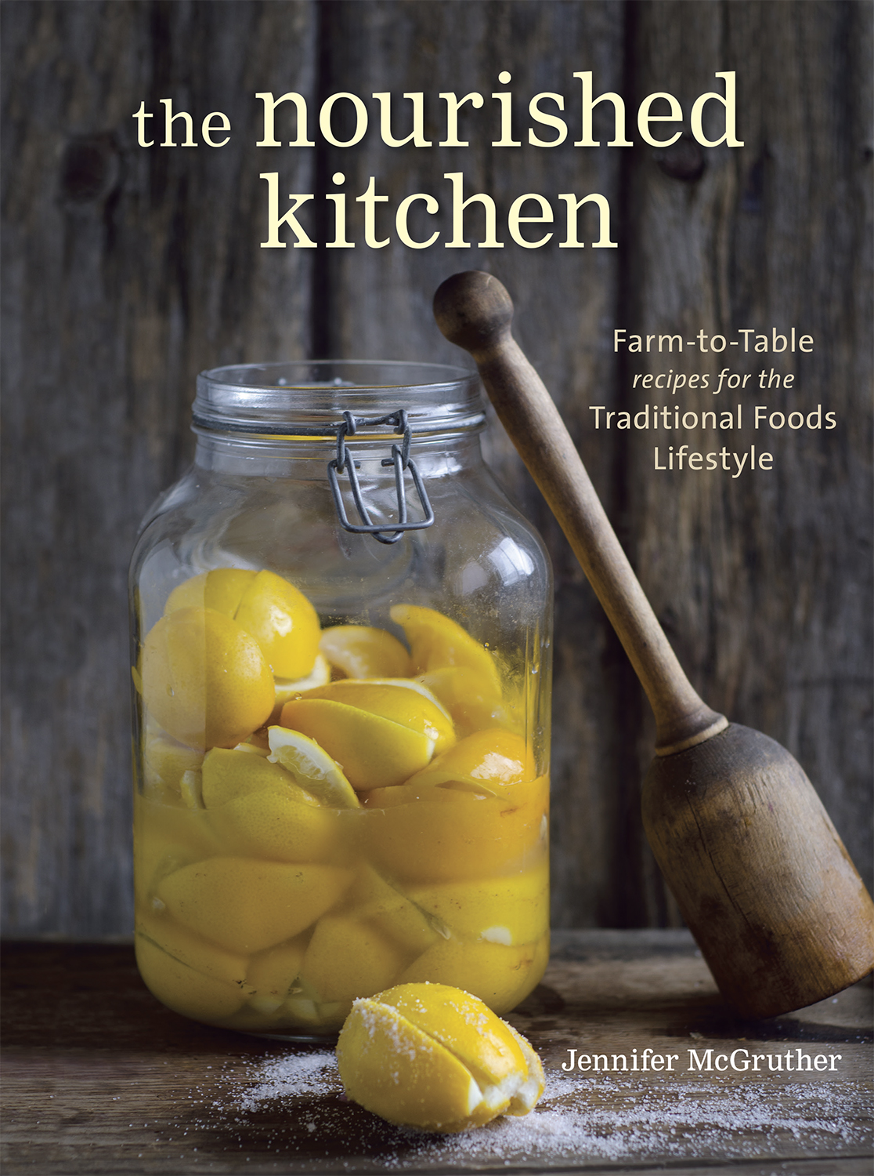[*Barnes and Noble*](http://www.barnesandnoble.com/w/the-nourished-kitchen-jennifer-mcgruther/1115696885?ean=9781607744689) | [*Amazon*](https://nourishedkitchen.com/recommends/broth-and-stock-nourished-kitchen/) | [*Indiebound*](http://www.indiebound.org/book/9781607744689)

*[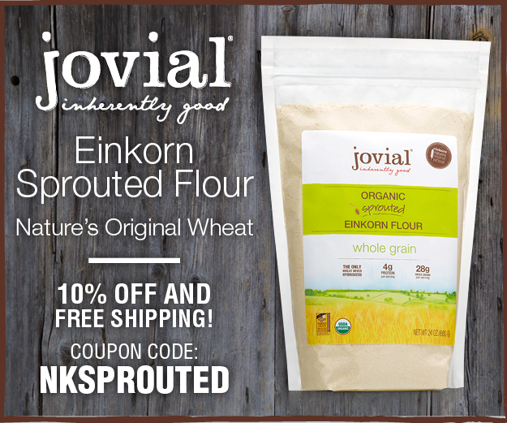](https://nourishedkitchen.com/recommends/sprouted-einkorn-flour/)*

Report this ad

*[https://d2cgumzzqhgmdu.cloudfront.net/assets/small-dd798fdf2451742a7f2a814cbed52a99fedef028b8a1ced99c1e856a2206286c.png](http://www.mediavine.com/)*

*Footer*

[](http://nourishedkitchen.com/)

RECIPES

by course

* [Meat & Fish](https://nourishedkitchen.com/course/meat-poultry-fish/)
* [Soups & Stews](https://nourishedkitchen.com/course/soups-stews/)
* [Sweets & Snacks](https://nourishedkitchen.com/course/sweets-treats/)
* [Veggies](https://nourishedkitchen.com/course/vegetable-side-dishes-course/)
* [Breakfasts](https://nourishedkitchen.com/course/breakfasts/)
* [Drinks](https://nourishedkitchen.com/course/beverages/)
* [Breads](https://nourishedkitchen.com/course/breads-course/)
* [Sauces](https://nourishedkitchen.com/course/condiments-sauces/)
* [Ferments](https://nourishedkitchen.com/course/fermented-cultured-foods/)
* [Grains](https://nourishedkitchen.com/course/grains-starchy-sides/)
* [Salads](https://nourishedkitchen.com/course/salad-salad-dressing/)

by diet

* [GAPS & SCD](https://nourishedkitchen.com/food-sensitivity-dietary-preference/gaps-friendly/)
* [Paleo & Primal](https://nourishedkitchen.com/food-sensitivity-dietary-preference/paleoprimal/)
* [Gluten-free](https://nourishedkitchen.com/food-sensitivity-dietary-preference/gluten-free-food-sensitivity-dietary-preference/)
* [Dairy-free](https://nourishedkitchen.com/food-sensitivity-dietary-preference/dairy-free/)
* [Vegetarian](https://nourishedkitchen.com/food-sensitivity-dietary-preference/vegetarian-food-sensitivity-dietary-preference/)
* [Vegan](https://nourishedkitchen.com/food-sensitivity-dietary-preference/vegan-food-sensitivity-dietary-preference/)

by season

* [Winter](https://nourishedkitchen.com/season/winter-season/)
* [Spring](https://nourishedkitchen.com/season/spring-season/)
* [Summer](https://nourishedkitchen.com/season/summer-season-2/)
* [Autumn](https://nourishedkitchen.com/season/autumn/)

JOIN OUR COMMUNITY

*Wholesome cooking doesn’t have to be hard. Sign up to receive recipes and insight on how to eat, live, and thrive – naturally.*

Top of Form

First NameEmail Address

Bottom of Form

* [© 2016 Nourished Kitchen](http://nourishedkitchen.com/)

* [About](https://nourishedkitchen.com/about-the-nourished-kitchen/)

* [Press & Media](https://nourishedkitchen.com/about-the-nourished-kitchen/press-awards/)

* [Blog](https://nourishedkitchen.com/traditional-foods-blog/)

* [Contact](https://nourishedkitchen.com/contact-me/)

* [Terms, Conditions and Policies](https://nourishedkitchen.com/disclaimer/)
* **Ingredients:**
* 1 quart fresh milk
* 2 tbsp starter OR
* 2 tbsp yogurt from a previous batch OR
* 2 tbsp plain, unsweetened, additive-free yogurt with live active cultures found at any grocery store

**Instructions:**

1. Heat milk in a saucepan over a medium-low flame until it reaches about 110° Fahrenheit
2. Remove from heat and whisk in 2 tablespoons yogurt culture such as Bulgarian or Greek starter or use two tablespoons yogurt from a previous batch or the store to inoculate the raw milk.

*Tips and Tricks: Easy Goat Milk Yogurt*

*Finding An Agent That’s Right For You*

***coming soon >>>***