Saanen  Buck: Starlight Hills Simeon  DOB: 2/26/14  Consigner: Barb Knilans  Doe: Starlight Hills Whisper  DOB: 2/22/14  Consigner: Barb Knilans  Oberhasli  Buck: Hintz’s Olaf  DOB: 2/23/14  Consigner: Jake Hintz  Doe: Starlight Hills Katrina  DOB: 3/16/14  Consigner: Barb Knilans  Toggenberg  Doe: Legendairy Chip’s Rhicotta  DOB: 3/3/14  Consigner: Anna Thompson-Hajdik  Recorded Grade  Doe: Fauna Farm Kim’s Kylie  DOB: 3/10/14  Consigner: Erica Lamers |  |  | More information and pedigrees can be found on the WDGA website @ www.WDGA.org and the WDGA Facebook page.  Arlington Agricultural Research Station  N695 Hopkins Road  Arlington, WI 53911  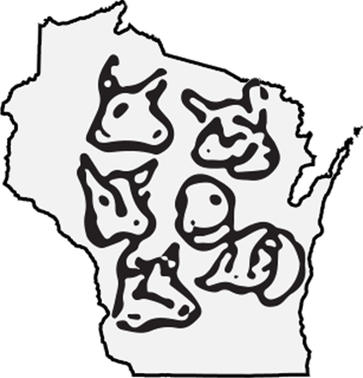 Wisconsin Dairy Goat Association |  |  | 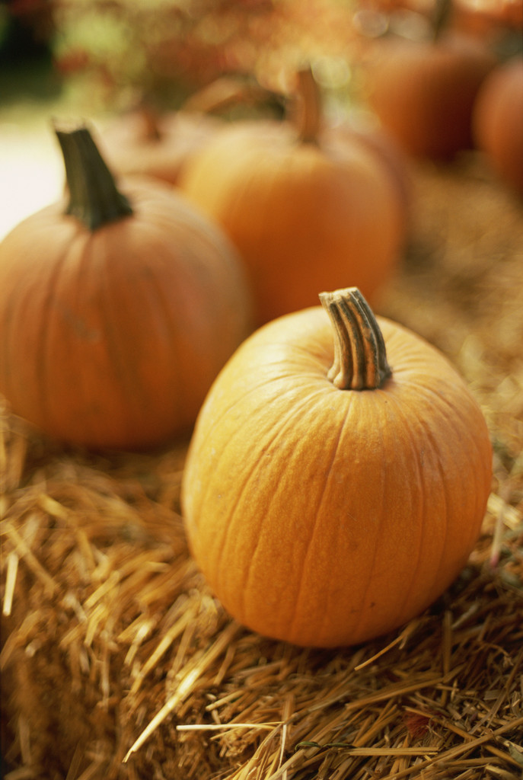  Arlington Fall Field Day  Wisconsin Dairy Goat Association  - October 11, 2014  - Arlington Ag Research Station  Public Events Building

Admission  Members $10.00  Couple $15.00  Non-member $15.00  Couple $20.00  Membership Dues $25.00  (includes membership, breeder listing, one  website listing)  Kids 18 and under FREE  Vendor fee $25.00  Lunch Available  Youth Events  10:00-11:30 Youth Classroom |  |  | Schedule  9:00-10:00 Registration  10:00-11:30 Peer Teaching AI Clinic  Kiki Brackett (Sunburst Dairy Goats, top 10 breed leaders, 4-H leader)  Mary Adamson (Mar-Ran Dairy Goats-AI breeding for 7 yrs, breeds 6 to 10 does per year with a success rate of 80 to 85%.)  Victoria Tonn (Hillside Pines Dairy Goats, AI’ed goats and white tailed deer)  10:00-11:30 Tamara Taylor  ADGA Sr Judge from TX. Will speak on livestock guardian dogs  11:30-1:00 LUNCH, Social time; Preview of animals  1:00-3:00 Tamara Taylor  ADGA Judge from TX. Will speak on selection of animals. This session is gear toward the youth and novice breeders.  1:00-3:00 University Spokesperson  Dairy meat goat cost and gain study results; update on the Goat/Sheep position with the UW.  3:30-4:00 Raffle  4:00 Ben Brancel/Auction  Wisconsin Department of Ag update; will auction animals
Select Sale Animals
Alpine
Buck: Marran River’s Redd
DOB: 3/4/14
Consigner: Marran Dairy Goats

Doe: Sunshine Tea Rosi
DOB: 3/4/14
Consigner: Dan Considine

Lamancha
Buck: RPS Acres Zircon
DOB: 4/4/14
Consigner: Hannah Shilts

Doe: Elm Glen Bric Brisset
DOB: 4/21/13
Consigner: Jennifer
Loman- Petersen

Nubian
Doe: Acorn Ridge Glamour Lady
DOB: 4/29/14
Consigner: Jason Puterbaugh

Nigerian Dwarf
Doe: Sugar Bottom Goats Candy
DOB: 5/24/14
Consigner: Mason Spencer

